English Translation

Only once (initially):

Scan me to connect to the Church WLAN
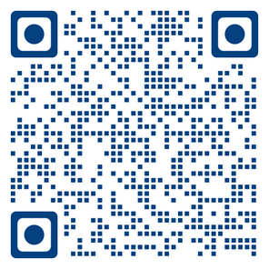
QR-Code 1

or connect manually to the follow WLAN
WLAN Name: translation
WLAN Password: translation

Every Sunday:

Connect to the English Translation System

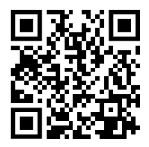
Scan ME to connect to Jitsi
QR-Code 2

Follow the instruction on the next page
If you cannot scan the above QRCode open a browser (Chrome or Firefox) and type the follow address:
https://translation.sennsolutions.com/eng

Safari on IPhone not always work properly. Please use Chrome or Firefox.

Preferred option 1 (Launch in Browser). You do not need to install anything.
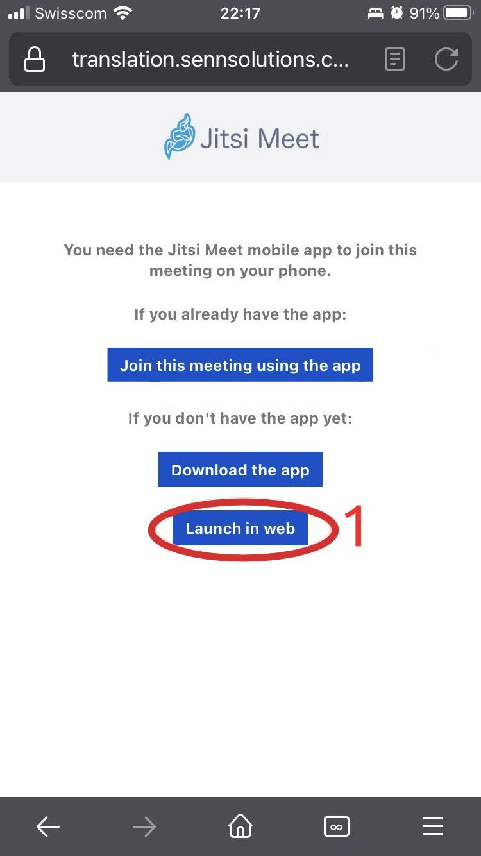

Select Launch in Web

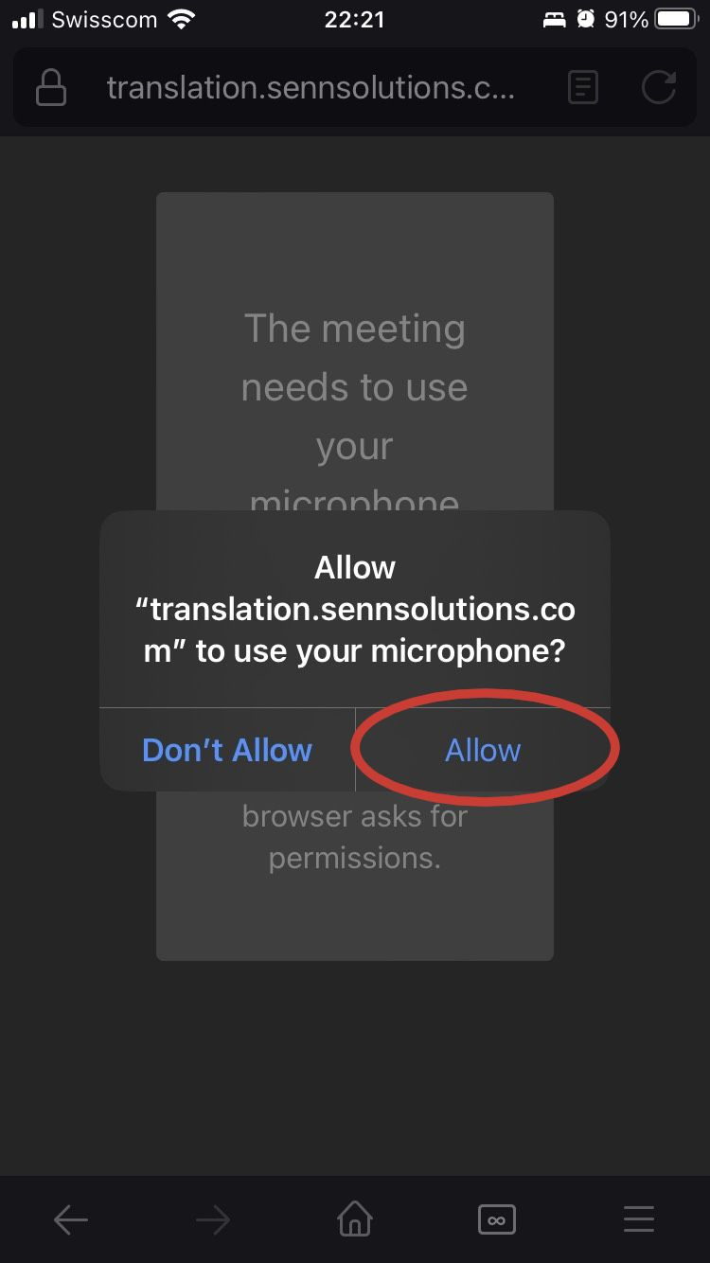
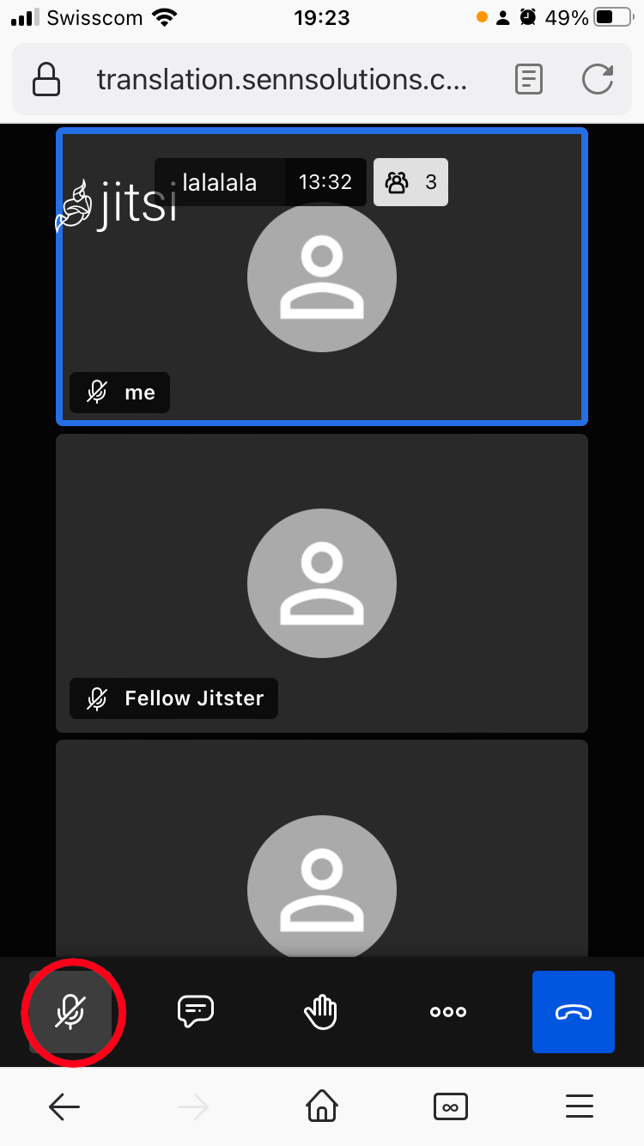

Press Allow

Mute yourself, if not already muted

Option 2 - With the Jitsi App
Click on OK:
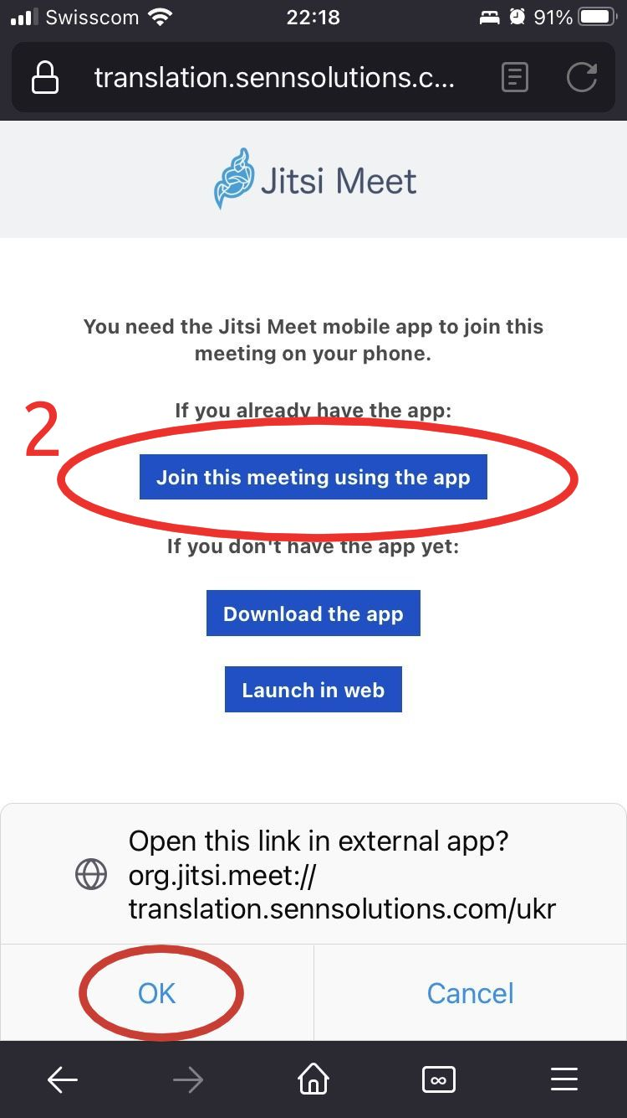

Select Join this meeting using the app

Switch off the Microphone  Switch off the Camera  Join the meeting | 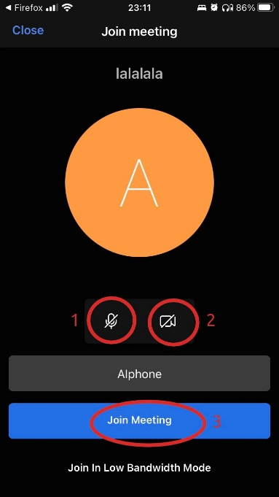

Option 3 - Manually from the Jitsi App
Open the Jitsi App.  (In the Jitsi App go to Settings and configure the options below - only once): | Write the Room Name "eng" and press the button JOIN
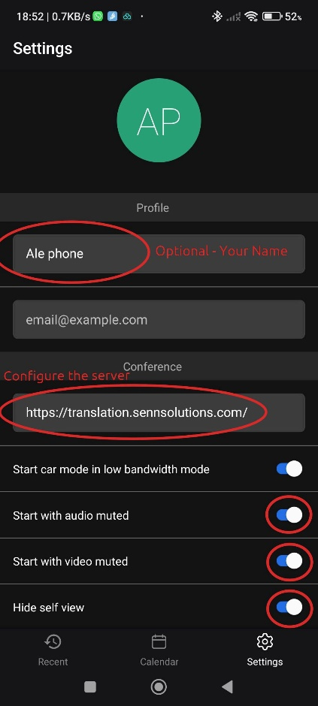 | 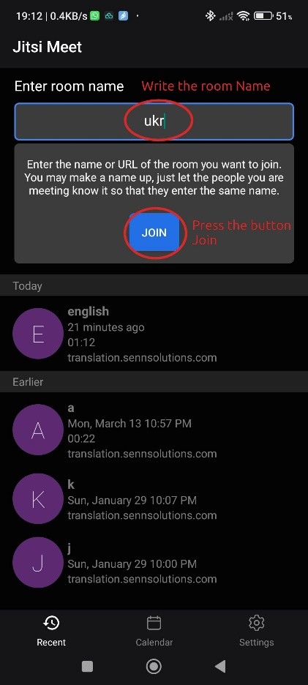

If you still cannot connect be sure to switch-off your Internet(Data) Connectivity. The translation works without any data plan. You need only the WIFI connection.
If also without Data Connection you cannot connect, check the private DNS setting on your Android phone and disable it and retry to connect with the QR-Code 2.

Search in the phone setting for “private”, select “Private DNS” and set it to Off.  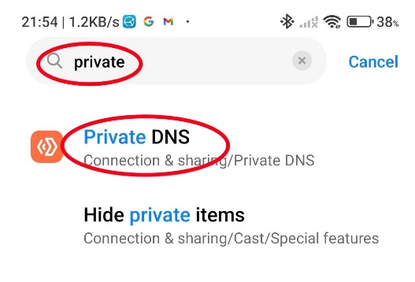 | 